Date | Version | Author
10.2014 | V8 | Albert Merz

HYDROCAL 1008
Order sheet including accessories

Necessary information and standard accessories
Pos. | Description |  | Quantity
010 | Power supply
 | Nominal voltage version | Supply voltage
 | 120 V -20% +15% AC 50/60Hz | 96 V_{min} ... 138 V_{max} AC 50/60Hz | 0
 | 230 V -20% +15% AC 50/60Hz | 184 V_{min} ... 264 V_{max} AC 50/60Hz | 0
 | 120 V -20% +15% DC | 96 V_{min} ... 138 V_{max} DC | 0
 | 230 V -20% +15% DC | 184 V_{min} ... 264 V_{max} DC | 0
020 | Connection unit thread
 | G 1½” DIN ISO 228-1 |  | 0
 | 1½” NPT ANSI B 1.20.1 |  | 0
030 | Communication interface ETHERNET 10/100Mbit/s
 | Copper wired - RJ45 |  | 0
 | Fibre optical - SC Duplex |  | 0
040 | Configuration Digital Relay Output 1
 | Normally Open (Standard) | Normally Closed
050 | Manual for installation and operation
 | German |  | 0
 | English |  | 0
060 | Test certificate
 | German |  | 0
 | English |  | 0
 | Russian |  | 0
070 | Installation on
 | new Transformer |  | 0
 | old Transformer |  | 0

Optional accessories
Pos. | Description |  |  |  |  |  |  |  |  |  |  |  | Quantity
110 | On-Board Modem (Analog) with connection cable L = 15 m
 | 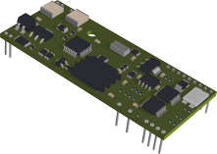 |  |  |  |  |  | 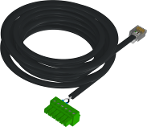 |  |  |  |  |  | 0
120 | On-Board Modem (GSM) with connection cable and GSM antenna
 | 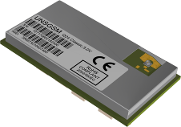 |  |  |  | 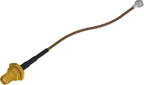 |  |  |  | 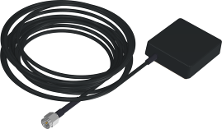 |  |  |  | L = 3 m
 |  |  |  |  |  |  |  |  |  |  |  |  | 0
 |  |  |  |  |  |  |  |  |  |  |  |  | L = 5 m
 |  |  |  |  |  |  |  |  |  |  |  |  | 0
130 | On-Board Modem (DNP3)
 | 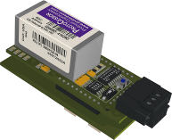 |  |  |  |  |  |  |  |  |  |  |  | 0
140 | On-Board Modem (IEC61850) with patch cable, shielding cover and connection card – Note: only possible with communication interface ETHERNET copper wired - RJ45
 | 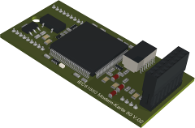 |  |  |  | 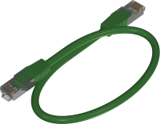  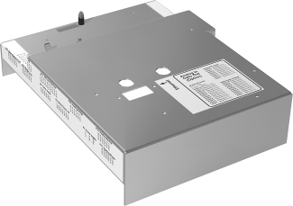 |  |  |  | 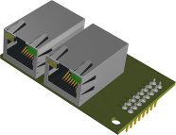  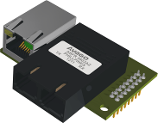 |  |  |  | RJ45
 |  |  |  |  |  |  |  |  |  |  |  |  | 0
 |  |  |  |  |  |  |  |  |  |  |  |  | SC Duplex
 |  |  |  |  |  |  |  |  |  |  |  |  | 0
150 | Measurement input- and opto-coupler output card
 | 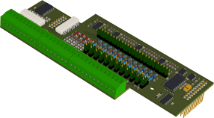 |  |  |  |  |  |  |  |  |  |  |  | 0
 | Configuration Analog AC Inputs
 | Current 0/4 … 20 mA (Standard) |  |  |  |  |  | Voltage 0 … 80 V
 | In1 | In2 | In3 | In4 | In5 | In6 | In1 | In2 | In3 | In4 | In5 | In6

160 | Commissioning / training
 | Number of days by EMH | 0
 | Number of days by MTE | 0

Additional information
End customer
Name
Address
Street
City
Country
Substation
Name
Address
Street
City
Country
Transformer
Manufacturer
Manufacturing Year
Serial Number
Power Rating [MVA]
Voltage Rating [kV]

Remarks

