Date | Version | Author
10.2014 | V8 | Albert Merz

HYDROCAL 1003
Order sheet including accessories

Necessary information and standard accessories
Pos. | Description |  |  |  |  |  |  |  | Quantity
010 | Power supply
 | Nominal voltage version |  |  |  | Supply voltage
 | 120 V -20% +15% AC 50/60Hz |  |  |  | 96 V_{min} ... 138 V_{max} AC 50/60Hz |  |  |  | 0
 | 230 V -20% +15% AC 50/60Hz |  |  |  | 184 V_{min} ... 264 V_{max} AC 50/60Hz |  |  |  | 0
 | 120 V -20% +15% DC |  |  |  | 96 V_{min} ... 138 V_{max} DC |  |  |  | 0
 | 230 V -20% +15% DC |  |  |  | 184 V_{min} ... 264 V_{max} DC |  |  |  | 0
020 | Connection unit thread
 | G 1½” DIN ISO 228-1 |  |  |  |  |  |  |  | 0
 | 1½” NPT ANSI B 1.20.1 |  |  |  |  |  |  |  | 0
030 | Configuration Analog DC Inputs
 | Current 0/4 … 20 mA (Standard) |  |  |  | Voltage 0 … 10 V
 | In1 | In2 | In3 | In4 | In1 | In2 | In3 | In4
040 | Manual for installation and operation
 | German |  |  |  |  |  |  |  | 0
 | English |  |  |  |  |  |  |  | 0
050 | Test certificate
 | German |  |  |  |  |  |  |  | 0
 | English |  |  |  |  |  |  |  | 0
 | Russian |  |  |  |  |  |  |  | 0
060 | Installation on
 | new Transformer |  |  |  |  |  |  |  | 0
 | old Transformer |  |  |  |  |  |  |  | 0

Optional accessories
Pos. | Description |  |  |  | Quantity
110 | On-Board Modem (Analog) with connection cable L = 15 m
 | 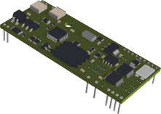 |  | 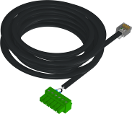 |  | 0
120 | Modem (GSM) with connection cable and GSM antenna
 | 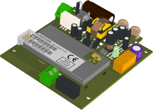 | 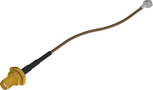 |  | 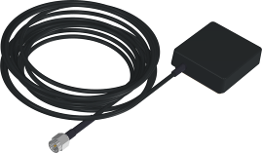 | L = 3 m
 |  |  |  |  | 0
 |  |  |  |  | L = 5 m
 |  |  |  |  | 0
130 | Communication interface ETHERNET 10/100Mbit/s (Copper wired)
 | 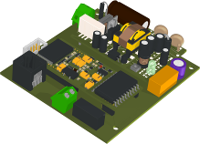 |  |  |  | 0
140 | Communication interface ETHERNET 10/100Mbit/s (Fibre optical)  with media converter SC-Duplex and RJ45 patch cable
 | 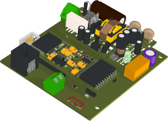 | 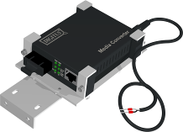 |  | 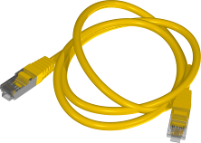 | 0
150 | Modem (DNP3)
 | 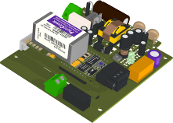 |  |  |  | 0
160 | On-Board Modem (IEC61850) with shielding cover and connection card
 | 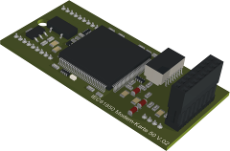 | 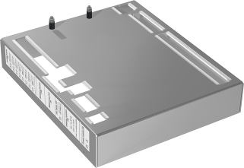 |  | 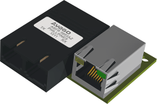 | 0
170 | Commissioning / training
 | Number of days by EMH |  |  |  | 0
 | Number of days by MTE |  |  |  | 0

Additional information
End customer
Name
Address
Street
City
Country
Substation
Name
Address
Street
City
Country
Transformer
Manufacturer
Manufacturing Year
Serial Number
Power Rating [MVA]
Voltage Rating [kV]

Remarks

